System testing is a big part of a validation and verification process, it is intended to show that a certain software or program meets its requirements and does what it is built for, as well as discovering defects before publishing it or putting it into use.
For this sake, we are using a third party extension as suggested called the iMacros, it somehow uses artificial data to execute and test the functionalities and non-functional attributes of the program. Below are screenshots of the use of iMacros.

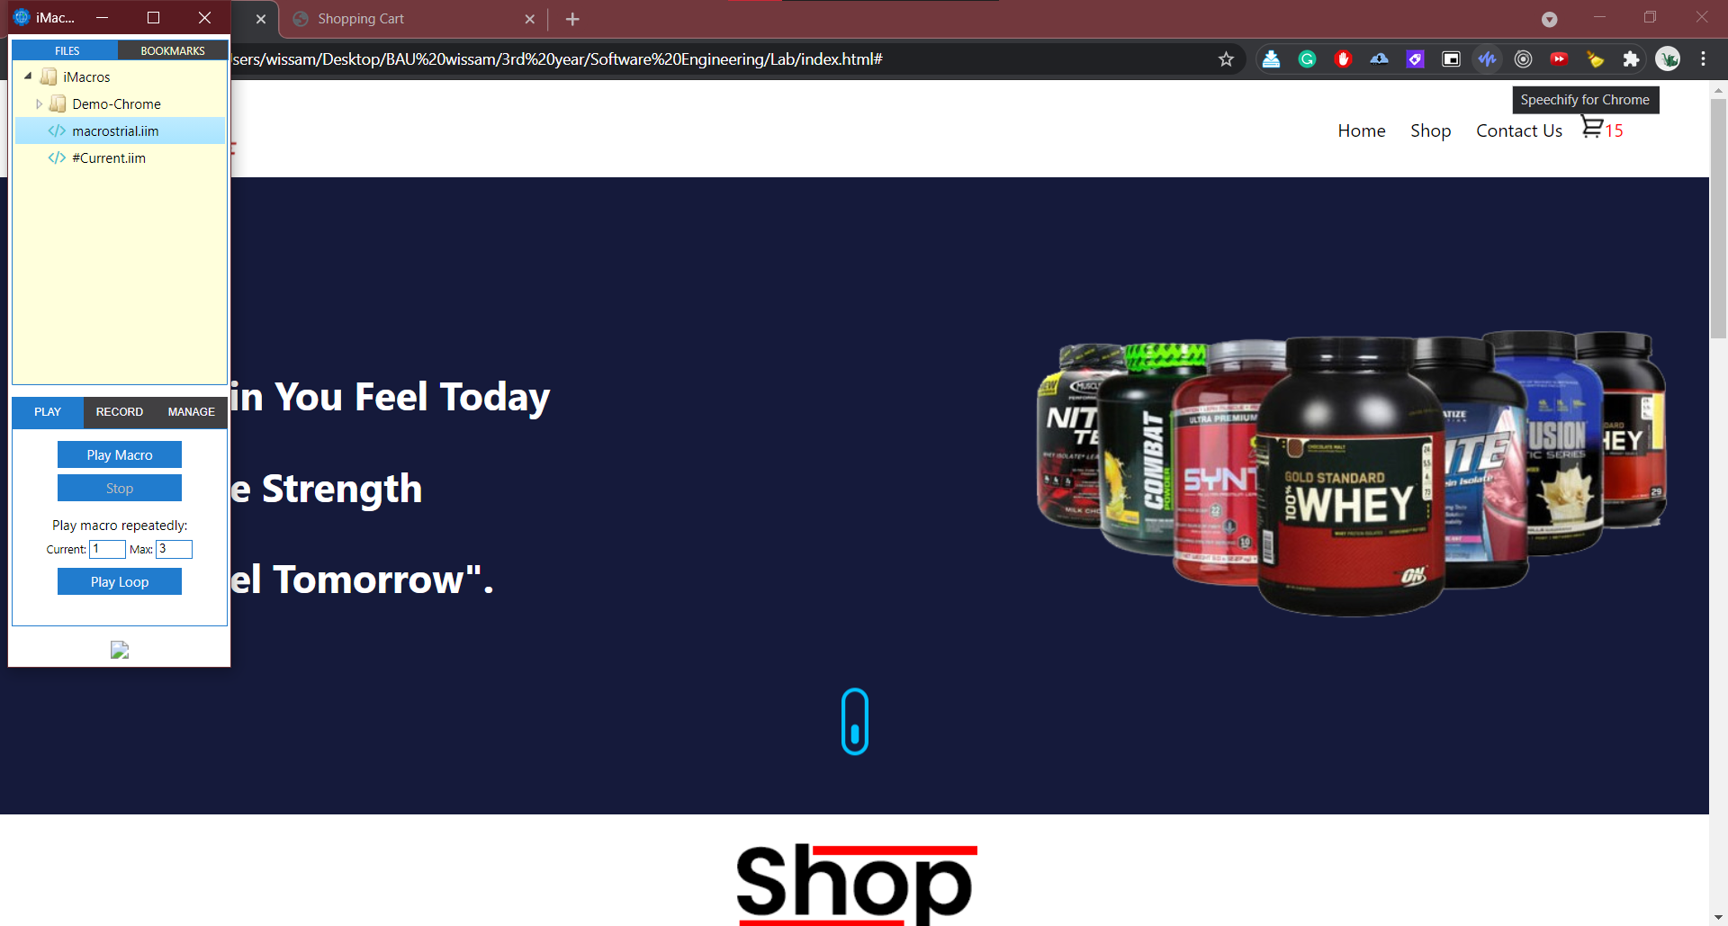

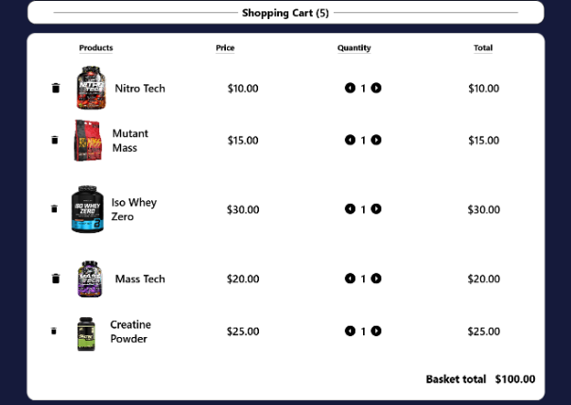
Another type of testing and validation of sustainability and scalability of a software in different environments and OS’s (or in our case different web browsers)
Here are some trials using browserstack.com

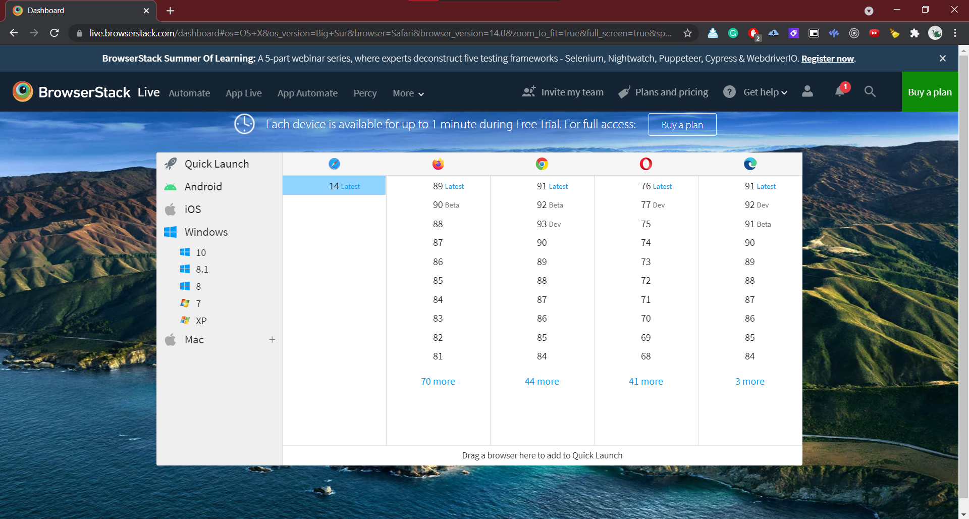

This site provides a huge variety of tools that help give a better insight to what the software could look like for many types of users, and what are some common defects that need to be fixed or tuned. More manual testing for an overall better outputted and cleaner software.

